**Report [2]**

**Car Internal Combustion Engine**

**Technical Writing**

**Dr. Ahmed Emad ElDin**

**Names:**

* Ibrahim Moustafa Ibrahim Fatouh ElShenhapy

**ID:** 4715 **Period:** Monday 3:20-4:50

* Mahmoud Adel Osman

**ID:** 4647 **Period:** Wednesday 5:00-6:30

* Ahmed Mohamed AbdelKader

**ID:** 4649 **Period:** Monday 3:20-4:50

* Ahmed Mohamed Farouk Ibrahim

**ID:** 4622 **Period:** Monday 5:00-6:30

***Car Internal Combustion Engine***

A Car internal combustion engine is an engine in which fuel and air combust inside the engine to create the energy in order to move the pistons, which in turn move the car. Chemical energy of the fuel is converted to thermal energy and thermal energy is converted to mechanical energy. **[1]**

This contrasts with external combustion engines, such as [steam engines](http://www.newworldencyclopedia.org/entry/Steam_engine), which use the combustion process to heat a separate working fluid, typically water or steam, which then in turn does work. **[1]**

Internal combustion engines provide outstanding drivability and durability, with more than 250 million highway transportation vehicles in the United States relying on them. Along with gasoline or diesel, they can also utilize renewable or alternative fuels (e.g., [natural gas](https://www.energy.gov/eere/energybasics/articles/natural-gas-vehicle-basics), [propane](https://www.energy.gov/eere/energybasics/articles/propane-vehicle-basics), [biodiesel](https://www.energy.gov/eere/energybasics/articles/biodiesel-fuel-basics), or [ethanol](https://www.energy.gov/eere/energybasics/articles/flexible-fuel-vehicle-basics)).  They can also be combined with hybrid electric powertrains to increase fuel economy or plug-in hybrid electric systems to extend the range of [plug-in hybrid electric vehicles](https://www.energy.gov/eere/energybasics/articles/hybrid-and-plug-electric-vehicle-basics). **[2]**

An internal combustion engine depends on four distinct piston strokes to complete one operating cycle, as shown in [***Figure (1)***]. The piston make two complete passes in the cylinder to complete one operating cycle. An operating cycle requires two revolutions (720°) of the crankshaft. A four-stroke cycle engine completes the following four strokes: intake, compression, power and exhaust. **[3]**

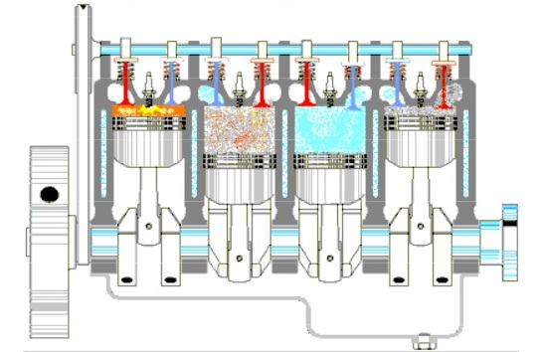

***Figure (1) the 4 process together* [3]**

**Step 1: Intake Stroke**

The intake stroke, shown in [***Figure (2)***], is the first stage of the combustion process is when the air-fuel mixture is introduced to fill the combustion chamber. The intake event occurs when the piston moves from top-dead-center (TDC) to bottom-dead-center (BDC) and the intake valve is open. The movement of the piston toward bottom creates a low pressure in the cylinder. **[1]**

Ambient atmospheric pressure forces the air-fuel mixture through the open intake valve into the cylinder to fill the low pressure area created by the piston movement. **[1]**

The cylinder continues to fill slightly past bottom as the air-fuel mixture continues to flow by its own inertia while the piston begins to change direction. The intake valve remains open a few degrees of crankshaft rotation after bottom-dead-center depending on engine design. The intake valve then closes and the air-fuel mixture is sealed inside the cylinder. **[2]**

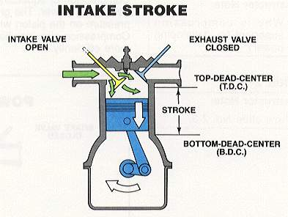

***Figure (2) Intake stroke* [2]**

**Step 2: Compression Stroke**

Compression Stroke is the second stroke of the four-stroke cycle, in which the piston starts from bottom dead center towards top dead center while both intake and exhaust valves are closed during this stage. **[3]**

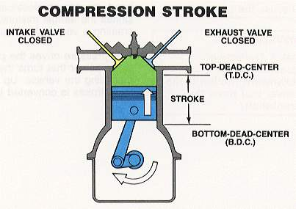 In this stroke, the piston moves from bottom, as we can see in the opposite figure [***Figure (3)***], to compress the air-fuel mixture in preparation for ignition during the next step ‘’ Power Stroke ‘’. **[6]**

***Figure (3) Compression Stroke* [2]**

**Step 3: Power Stroke**

Power stroke is the third stage of the process, at which the crankshaft has completed a full 360 degree revolution while the piston at the top-dead center (the end of compression stroke) and both valves are closed, which is clear in the picture below [***Figure (4)***].**[2]**

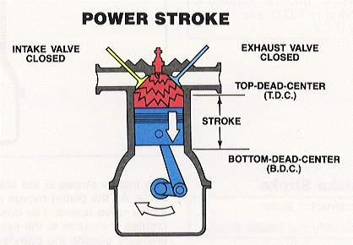 The compressed air-fuel mixture at this stage is ignited by a spark plug (in a gasoline engine) or by heat generated by high compression (diesel engines), forcefully returning the piston to bottom-dead-center. This stage produces a mechanical work from the engine moving the crankshaft. **[2]**

**Figure (4) Power stroke [2]**

**Step 4: Exhaust Stroke**

The exhaust stroke is the final stroke and it occurs when spent gases are expelled from the combustion chamber and released to the atmosphere while the exhaust valve is open and the intake valve is closed. Piston movement evacuates exhaust gases to the atmosphere as it is shown in the figure below [***Figure (5)***]. **[1]**

The piston reaches bottom-dead-center during the power stroke combustion is complete and the cylinder is filled with exhaust gases. The exhaust valve opens, and inertia of the flywheel and other moving parts push the piston back to top, forcing the exhaust gases out through the open exhaust valve. At the end of the exhaust stroke, the piston is at top-dead-center and one operating cycle has been completed. **[1]**

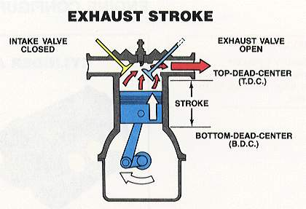

***Figure (5) Exhaust stroke* [2]**

Ever repetition of the cycle requires two full rotations of the crankshaft, while the engine only creates power during one of the four strokes. To keep the machine running, it needs the [small engine flywheel](https://www.briggsandstratton.com/na/en_us/support/faqs/browse/inspecting-flywheel-key.html). The power stroke creates momentum that pushes the flywheel’s inertia keeps it and the crankshaft turning during the exhaust, intake and compression strokes. **[7]**

At the end, we can see that combustion is the basic chemical process of releasing energy from a fuel and air mixture.  In an internal combustion engine, the ignition and combustion of the fuel occurs within the engine itself. The engine then partially converts the energy from the combustion to work. **[5]**

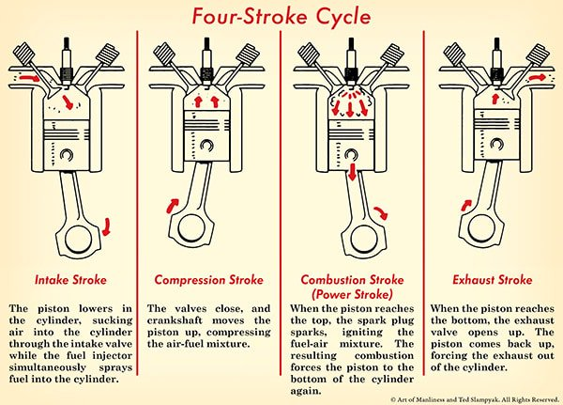 The below illustration [***Figure (6)***] summarizes the four-stroke cycle in a single cylinder. This is going on in the other cylinders as well. Repeat this cycle a thousand times in a minute, and you get a car that moves. **[7]**

***Figure (6) Four-Stroke Cycle* [1]**

***References:***

**Text:**

1. <http://www.mechanicstips.blogspot.com.eg>
2. <https://www.slideshare.net/yuvarajaraj37/ic-engine-by-yuvaraja>
3. <http://courses.washington.edu/engr100/Section_Wei/engine/UofWindsorManual/Four%20Stroke%20Cycle%20Engines.htm>
4. <https://www.briggsandstratton.com/na/en_us/support/videos/browse/4-cycle-theory.html>
5. <https://www.energy.gov/eere/energybasics/articles/internal-combustion-engine-basics>
6. <http://www.explainthatstuff.com/carengines.html>
7. <https://www.artofmanliness.com>

**Figures:**

1. <https://www.artofmanliness.com>
2. <http://www.mechanicstips.blogspot.com.eg>
3. [http://www.icym.edu.my/v13/about-us/our-news/general/896- internal-combustion-engine.html](http://www.icym.edu.my/v13/about-us/our-news/general/896-%20%20%20%20%20%20%20%20%20%20%20%20%20%20%20%20%20internal-combustion-engine.html)